Electrical Principals - Marking Scheme

|  |  |  |  |  |
| --- | --- | --- | --- | --- |
|  | Registration Number | Surname | Forename | % Contribution |
| Student 1 | 000874782 | Basharat | Usman | 25% |
| Student 2 | 000839875 | Turon | Kacper | 25% |
| Student 3 | 000871936 | Young | Jack | 25% |
| Student 4 | 000823208 | Ince | Ahmet | 25% |

|  |  |  |
| --- | --- | --- |
| **Task** | **Mark** | **Grade** |
| Task 0 - Electrical Units | 5 % |  |
| Task 1 - Voltage Measurement | 1 % |  |
| Task 2 - Voltage Measurements | 2 % |  |
| Task 3 - Potential Difference | 4 % |  |
| Task 4 - Resistor Codes | 5 % |  |
| Task 5 - Ohm's Law | 5 % |  |
| Task 6 - Oscilloscope Test | 10 % |  |
| Task 7 - Lissajous Figures | 4 % |  |
| Task 8 - Filter Graphs | 2 % |  |
| Task 9 - Filter Circuits | 2 % |  |
| Task 10 - Low Pass Filter | 20 % |  |
| Task 11 - Speed of Sound | 30 % |  |
| Task 12 – Reflection | 10 % |  |
| Total | 100 % |  |

COMP1588 Computer Systems Architectures

Laboratory #2

Electrical Principals

Usman Basharat – 000874782

Kacper Turon – 000839875

Jack Young – 000871936

Ahmet Ince - 000823208

Contents

[Abstract 3](#_Toc442132751)

[Introduction 3](#_Toc442132752)

[Methods and Materials 3](#_Toc442132753)

[Equipment/Material used: 3](#_Toc442132754)

[Software Used: 3](#_Toc442132755)

[Experimental Procedure 3](#_Toc442132756)

[Results 4](#_Toc442132757)

[Task 0 - Electrical Units 4](#_Toc442132758)

[Task 1 - Voltage Measurement 4](#_Toc442132759)

[Task 2 - Voltage Measurements 4](#_Toc442132760)

[Task 3 - Potential Difference 4](#_Toc442132761)

[Task 4 - Resistor Codes 5](#_Toc442132762)

[Task 5 - Ohm's Law 5](#_Toc442132763)

[Task 6 - Oscilloscope Test 5](#_Toc442132764)

[Task 7 - Lissajous Figures 6](#_Toc442132765)

[Task 8 - Filter Graphs 7](#_Toc442132766)

[Task 9 - Filter Circuits 7](#_Toc442132767)

[Task 10 - Low Pass Filter 8](#_Toc442132768)

[a) 8](#_Toc442132769)

[b) 8](#_Toc442132770)

[Task 11 11](#_Toc442132771)

[Task 12 – Reflection 16](#_Toc442132772)

[Conclusion 18](#_Toc442132773)

[References 19](#_Toc442132774)

# Abstract

This lab was all about Electronics. We had to get grips with using all the equipment. Task 6 required us to test us how well we know the oscilloscope. This required us to do the calculations, calculate the peak-to-peak, peak, RMS, the oscilloscope settings with its period and frequency. This all had to be complete within two minutes. We all had to practice beforehand in order to complete the task that had to be done. However, we all had to know how to setup the oscilloscope. We all felt that this task was one of the Tasks that needed to be revised on out of all.

# Introduction

This laboratory session was all about Electrical Principles. We were given a set of tasks to complete. There was 11 tasks to complete. Task 1, 8 and 9 required research and was done beforehand. The rest were complete during the two-week period. We were given clear instructions in order to complete these tasks.

# Methods and Materials

## Equipment/Material used:

* Lab Guide (Greenwich, 2016)
* DC Power Supply
* Oscilloscope
* Multi-meter
* True RMS Digital Multi-meter
* Function Generator
* Breadboard
* Loudspeaker
* Jump Wire Kit
* 1 Meter Ruler
* Oscilloscope Probe
* BNC to BNC cable
* BNC to Crocodile Clip cable
* BNC “T” Adaptor
* Banana Plug Test Probes

## Software Used:

* Microsoft Excel

# Experimental Procedure

For this laboratory session, we followed a guide provided by the University of Greenwich that told us what to do step by step. All steps were followed; no extra steps were taken when doing the exercise that was based on the guide.

# Results

|  |  |  |  |
| --- | --- | --- | --- |
| Quantity | Quantity Symbol | SI Unit | SI Unit Symbol |
| Potential Difference | E | Volts | V |
| Electric Current | C | Ampere | A |
| Charge | Q | Coulomb | C |
| Electric Power | W | watt | W |
| Resistance | R | Ohm | Ω |
| Inductance | L | Henry | H |
| Capacitance | C | Farad | F |
| Reactance | X | Ohms | Ω |
| Impedance | Z | Ohms | Ω |

## Task 0 - Electrical Units

## Task 1 - Voltage Measurement

Set the meter to the 20-volt DC range. Place the black probe tip on black (Gnd) terminal of the breadboard and the red multi-meter probe on the brown (Va) terminal of the breadboard. Record the voltage.

**4.98 V**

## Task 2 ­ - Voltage Measurements

|  |  |
| --- | --- |
| **Breadboard Terminals** | **Meter Reading (V)** |
| Green (Vb) to Brown (Va) | 7.96 V |
| Yellow (Vc) to Black (Gnd) | 9.98 V |
| Green (Vb) to Black (Gnd) | 0.00 V |
| Brown (Va) to Yellow (Vc) | 0.00 V |
| Brown (Va) to Black (Gnd) | 0.00 V |
| Green (Vb) to Yellow (Vc) | 0.00 V |

## Task 3 - Potential Difference

|  |  |  |
| --- | --- | --- |
| **Breadboard Terminals** | **Calculated Potential Difference (V)** | **Meter Reading (V)** |
| Green (Vb) to Brown (Va) | 0 | 10.11V |
| Yellow (Vc) to Black (Gnd) | 0 | -5.11 V |
| Brown (Va) to Yellow (Vc) | 0 | 5.11 V |
| Brown (Va) to Black (Gnd) | 0.01 – 0.00 = 0.01 V | 0.00 V |
| Green (Vb) to Yellow (Vc) | 0.03 – 0.01 = 0.02 V | 15.23 V |
| Green (Vb) to Black (Gnd) | 0.03 – 0.01 = 0.02 V | 10.12 V |

## Task 4 - Resistor Codes

|  |  |  |  |  |  |  |  |
| --- | --- | --- | --- | --- | --- | --- | --- |
| Resistor | 1st Digit Colour and Value | 2nd Digit Colour and Value | Multiplier Colour and Value | Tolerance Colour and value | Colour Code Value | Measured  Value | % Difference |
| Resistor 1 | Brown = 1 | Black = 0 | Red = 100 | Colour = gold  ±5% | 1 kΩ | 978 Ω | 2.2% |
| Resistor 2 | Brown = 1 | Black = 0 | Orange = 1000 | Gold = ±5% | 10 kΩ | 9.86kΩ | 1.4% |
| Resistor 3 | Red = 2 | Red = 2 | Red = 100 | Gold = ±5% | 2.2 kΩ | 2.17kΩ | 1.36% |

## Task 5 - Ohm's Law

|  |  |  |  |
| --- | --- | --- | --- |
| Resistor | Calculated Current | Measured Current | Calculated Power |
| 1 kΩ | I=12 V/1000 Ohms 0.012 A | 12.13 mA | P = 0.012 A\*12 V = 0.144 W |
| 10 kΩ | I = 12 V/10000 = 0.0012 A | 1.21 mA | P = 0.0012A\*12V = 0.0144 W |
| 100 kΩ | I = 12 V / 100 000 = 0.00012 A | 5.49 mA | P = 0.00012 A\*12 V = 0.00144 W |
| 1 MΩ | I = 12 V / 1 000 000 = 0.000012 A | 0.12 mA | P = 0.0000012 A\*12 V = 0.000144 W |

## Task 6 - Oscilloscope Test

|  |  |  |  |  |  |  |  |  |
| --- | --- | --- | --- | --- | --- | --- | --- | --- |
| Signal Type | Oscilloscope Setting Volts/Div | Peak - Peak  (Show Workings) | Peak (Show Workings) | Measured RMS (True RMS meter) | Calculated RMS (Show Workings) | Oscilloscope Setting Time/Div | Period (T) (Show Workings) | Frequency (f) (Show Workings) |
| Sinusoidal | 5 V | 20V 10-(-10)=20V  4 div \*5V = 20V | 2 div \*5V = 10V | 0.849 | 10V2 = 7.07 | 0.2 ms | T = 5 \*0.2 time/div \*10-3=0.001ms | f = 1/T = 1/0.001 = 1000 Hz |
| Square | 0.5 V | 4 div \* 5 V = 20 V | 2 div \*5 V = 10V | 1.173 | 10 | 0.2 ms | T = 5\*0.2time/div = 0.001 | f = 1/T = 1/0.001 = 1000 Hz |
| Triangle | 0.5 V | 4 div \* 5 V = 20 V | 2 div \*5 V = 10V | 0.651 | 10V3 = 5.77 | 0.2 ms | T = 5\*0.2time/div = 0.001 | f = 1/T = 1/0.001 = 1000 Hz |

## Task 7 - Lissajous Figures

Connect a second signal generator to the second input of the oscilloscope. Change the display type of the oscilloscope to X-Y display by pressing the X-Y button. The oscilloscope is now acting as an X-Y plotter. Keeping one output at 600 Hz, adjust the other frequency generator until a simple stable pattern is obtained, without too many loops. Record the frequencies and determine the relationship between the frequencies of the two signals and the number of loops present.

**First Frequency: 94.70 Hz**

**Second Frequency: 189.4 Hz**

Once we increased the frequency for the both signal generators, the number of loops increased. The number of loops that were present were two. As soon as the frequency changed, the number of loops changed. The higher the frequency on both signal generator, higher amount of loops. This specific frequency was reduced to obtain a pattern that was without too many loops. To do this, both of them needed to be at the point where there was not any. If either of the frequency increased, they were more loops.

## Task 8 - Filter Graphs

Identify which graphs represent, a low pass filter, a high pass filter, a band pass filter and band reject filter.

|  |  |  |  |  |
| --- | --- | --- | --- | --- |
| Filter Plot | | Filter Type | Filter Plot | Filter Type |
| Filter Plot | Low pass filter | Filter Plot | A band reject filter |
| Filter Plot | A band pass filter | Filter Plot | High pass filter |

## Task 9 - Filter Circuits

By considering the characteristics of capacitance and inductance. Identify which of the circuits is a low pass filter and a high pass filter

|  |  |  |  |
| --- | --- | --- | --- |
| Filter Circuit | Filter Type | Filter Circuit | Filter Type |
| Circuit | High | Circuit | Low |

## Task 10 - Low Pass Filter

### a)

|  |  |  |  |  |
| --- | --- | --- | --- | --- |
|  | Amplitude (V) | Frequency (Hz) | Volts/Div (V) | Time/Div |
| Channel 1 | 1.9 | 1000 Hz | 0.5 | 0.1ms |
| Channel 2 | 0.39 | 1000 Hz | 0.1 | 0.1ms |
| Channel 1 | 1.9 | 1500 Hz | 0.5 | 0.1ms |
| Channel 2 | 0.57 | 1500 Hz | 0.1 | 0.1ms |
| Channel 1 | 1.9 | 2000 Hz | 0.5 | 0.1ms |
| Channel 2 | 0.74 | 2000 Hz | 0.2 | 0.1ms |
| Channel 1 | 1.9 | 5000 Hz | 0.5 | 0.1ms |
| Channel 2 | 1.35 | 5000 Hz | 0.5 | 0.1ms |
| Channel 1 | 1.9 | 10 000 Hz | 0.5 | 20 nanos |
| Channel 2 | 1.7 | 10 000 Hz | 0.5 | 20 nanos |

### b)

|  |  |  |  |  |
| --- | --- | --- | --- | --- |
|  | Amplitude (V) | Frequency (Hz) | Volts/Div (V) | Time/Div |
| Channel 1 | 1.75 | 1000 Hz | 0.5 | 0.1ms |
| Channel 2 | 0.72 | 1000 Hz | 0.1 | 0.1ms |
| Channel 1 | 1.85 | 1500 Hz | 0.5 | 0.1ms |
| Channel 2 | 1 | 1500 Hz | 0.5 | 0.1ms |
| Channel 1 | 1.9 | 2000 Hz | 0.5 | 0.1ms |
| Channel 2 | 1.2 | 2000 Hz | 0.5 | 0.1ms |
| Channel 1 | 1.9 | 5000 Hz | 0.5 | 0.1ms |
| Channel 2 | 1.7 | 5000 Hz | 0.5 | 0.1ms |
| Channel 1 | 1.9 | 10 000 Hz | 0.5 | 0.1ms |
| Channel 2 | 1.8 | 10 000 Hz | 0.5 | 0.1ms |

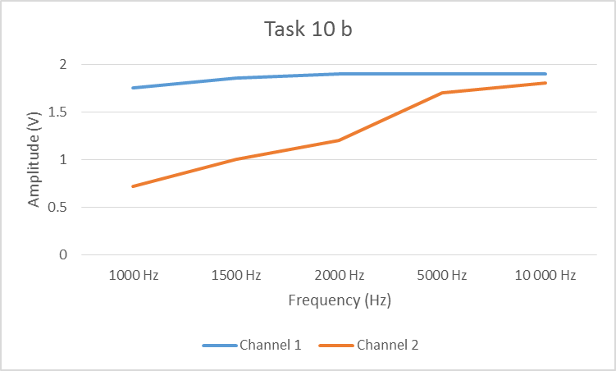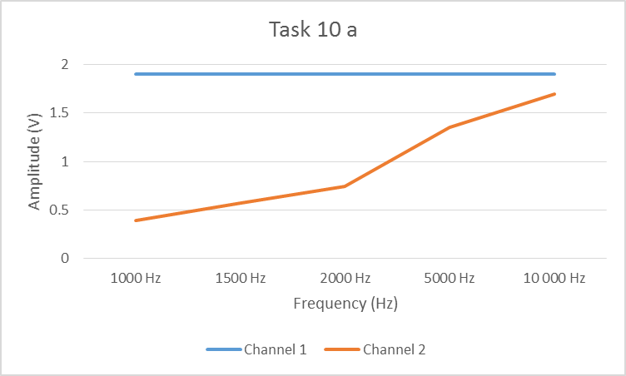

#### Pictures - Task 10

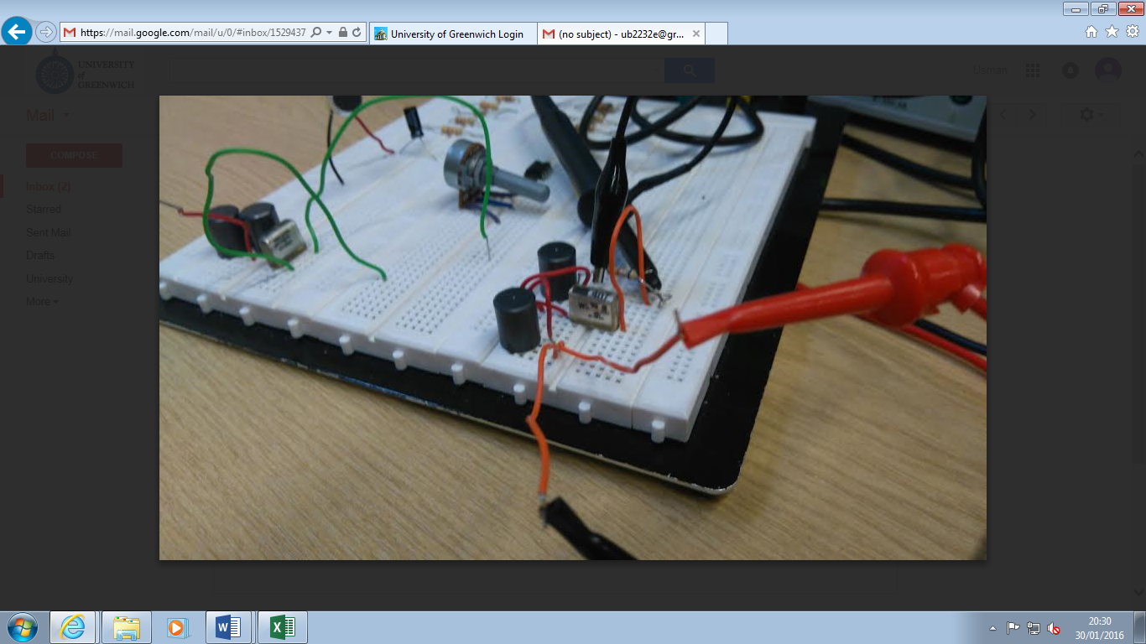

Figure – Task 10a breadboard setup

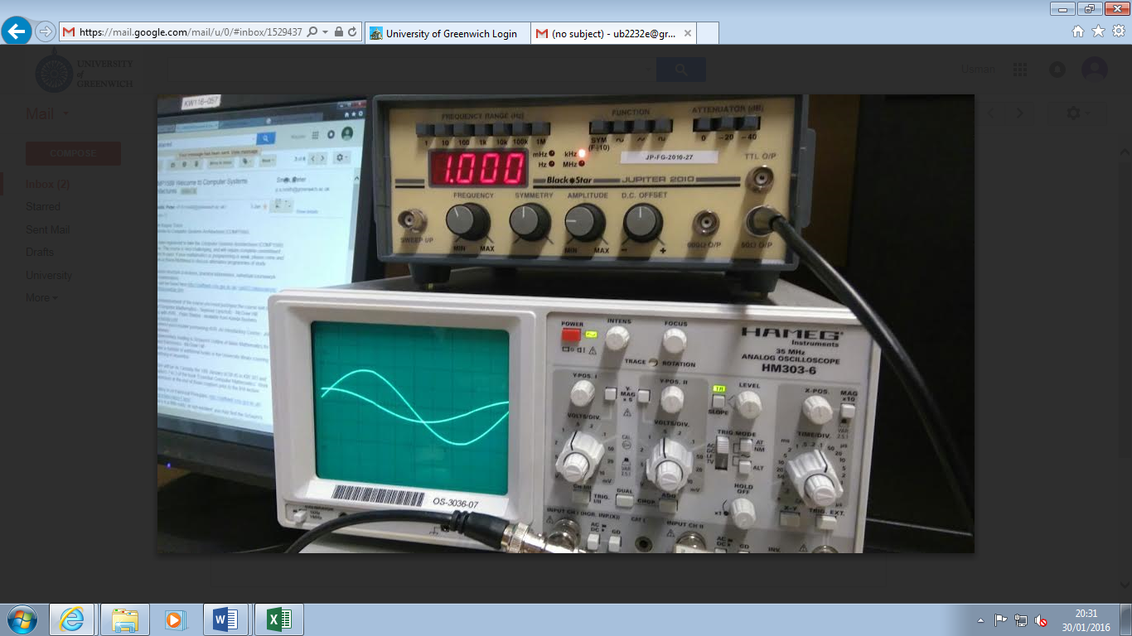

Figure – Task 10a oscilloscope and generator display

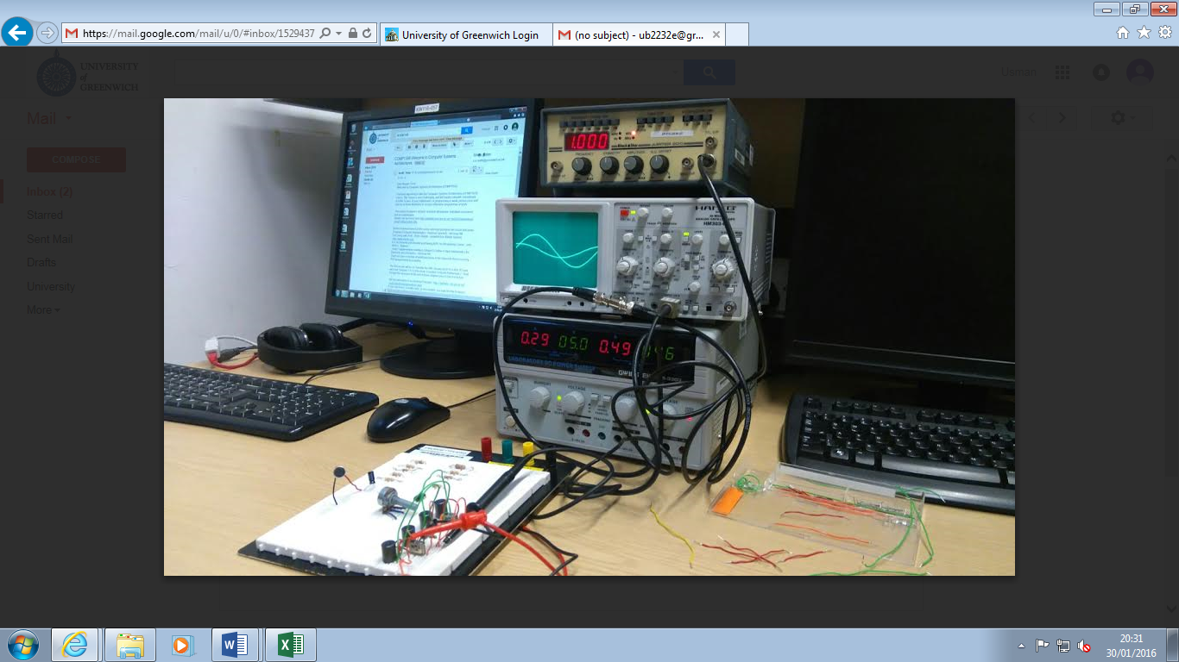

Figure – Task 10b overall view

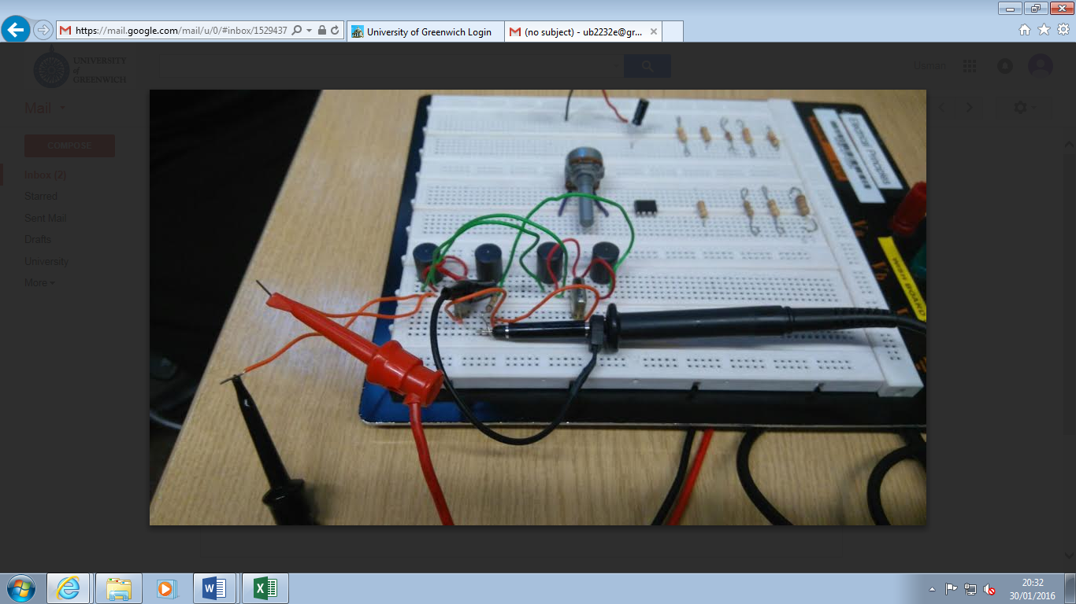

Figure – Task 10b breadboard setup

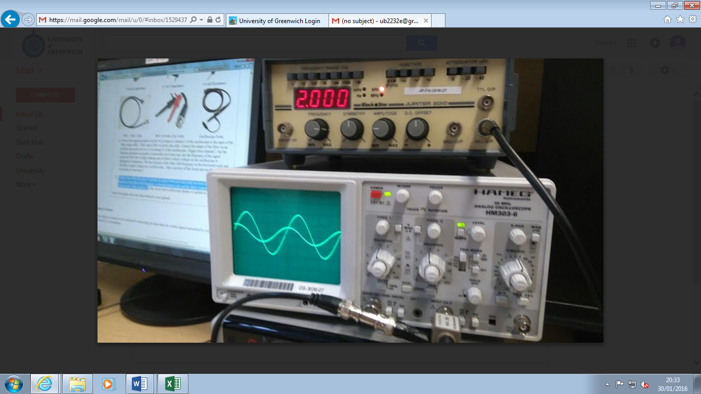

Figure - Task 10b oscilloscope and generator display

These pictures show what we did for Task 10. Each picture shows different parts of Task 10. Figure 1 shows us how the breadboard was constructed. Figure 2 and Figure 5 shows us the different type of frequencies that were used in this Task. Figure 3 and 4 are more pictures of the Task.

## Task 11

|  |  |  |  |  |
| --- | --- | --- | --- | --- |
| Distance (m) | Phase Measurement (1ms) | Phase Measurement (2ms) | Phase Measurement Average (ms) | Speed of Sound (m/s) |
| 0.05 | 1.5 | 1.2 | 1.35 | 0.05/0.35\*10-3 = 142.86 |
| 0.1 | 1.6 | 1.3 | 1.45 | 0.1/0.45\*10-3 = 222.22 |
| 0.15 | 1.6 | 1.3 | 1.45 | 0.15/0.45\*10-3 = 333.33 |
| 0.2 | 1.7 | 1.4 | 1.55 | 0.2/0.55\*10-3 = 363.63 |
| 0.25 | 1.8 | 1.5 | 1.65 | 0.25/0.65\*10-3 = 384.62 |

Table

#### C:\Users\ub2232e\AppData\Local\Microsoft\Windows\Temporary Internet Files\Content.IE5\SAMQQ7ID\20160201_133826.jpgPictures – Task 11

Figure – DC Power Supply

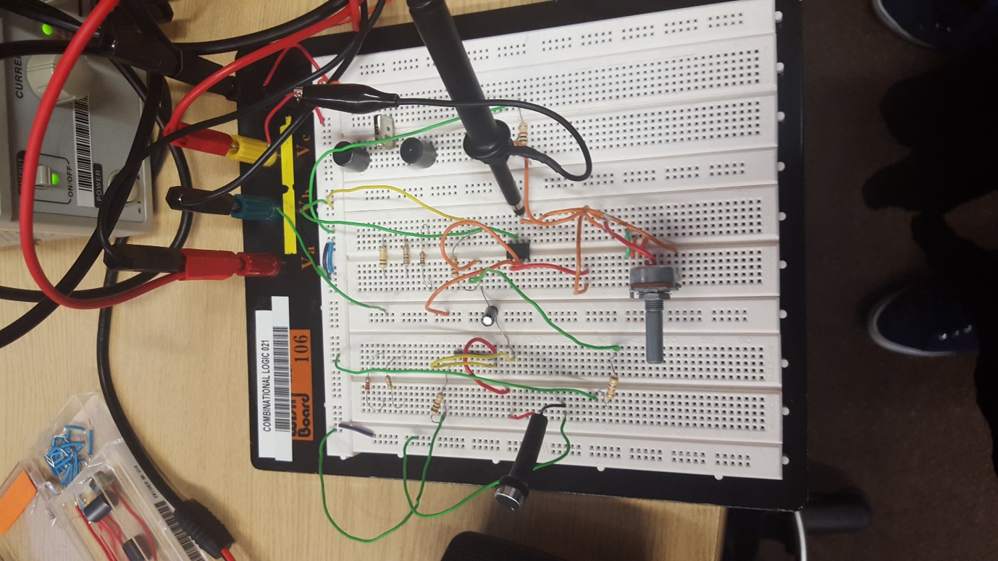

Figure – Breadboard setup

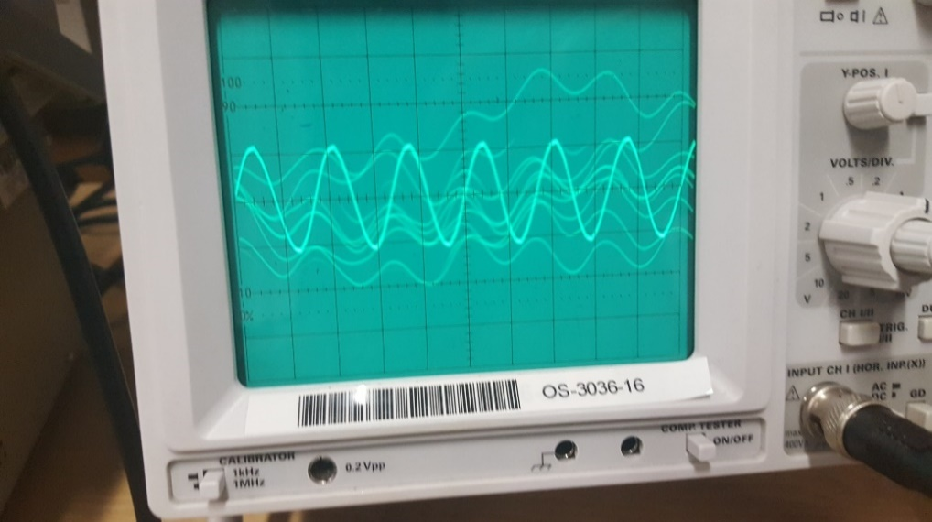

Figure – Oscilloscope when tapping microphone

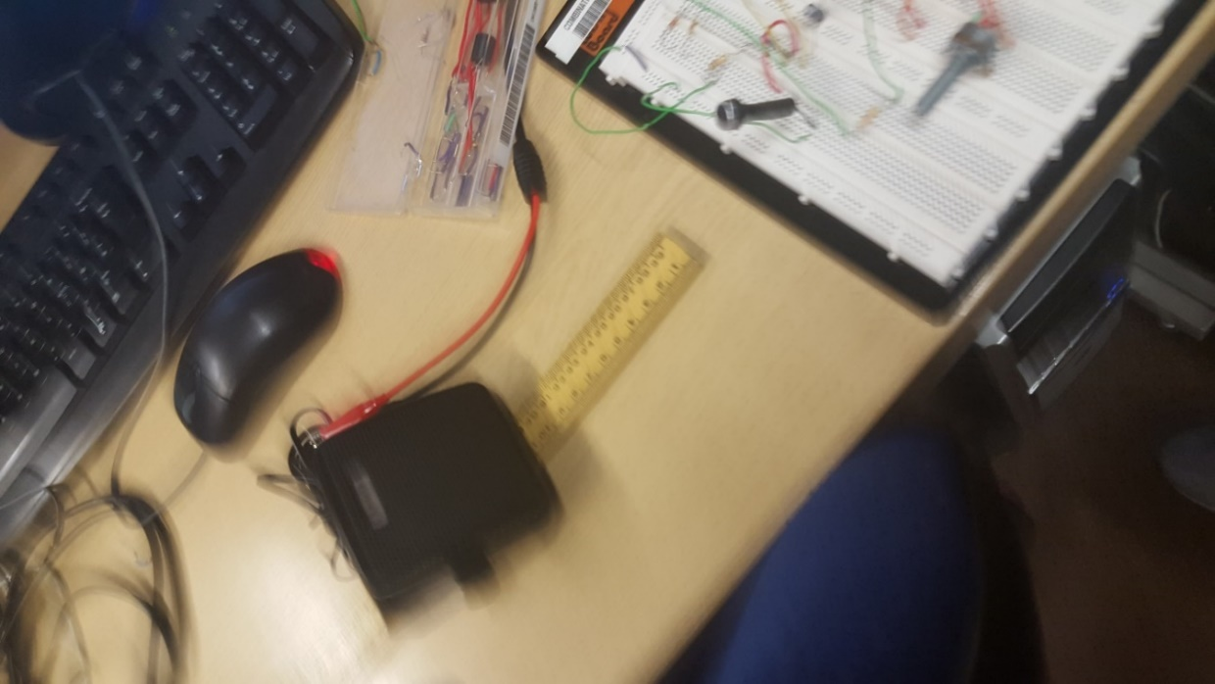

Figure – Ruler which measures the distance in cm from microphone and speaker

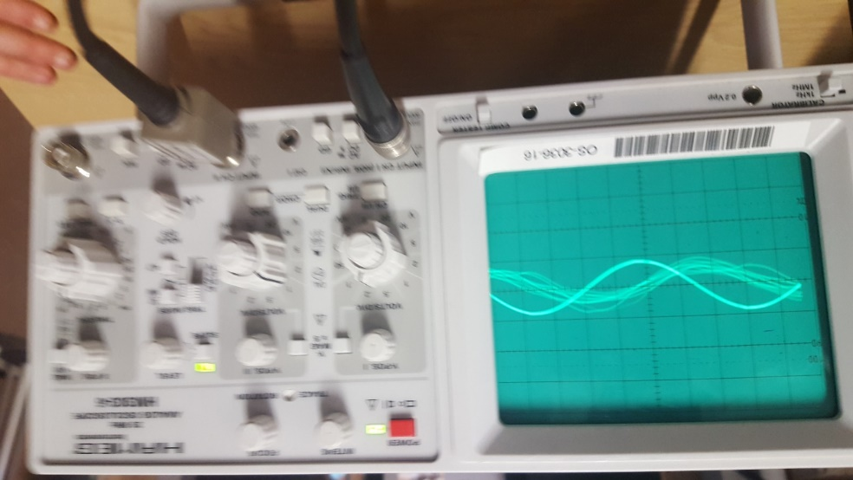

Figure – Oscilloscope when talking in microphone

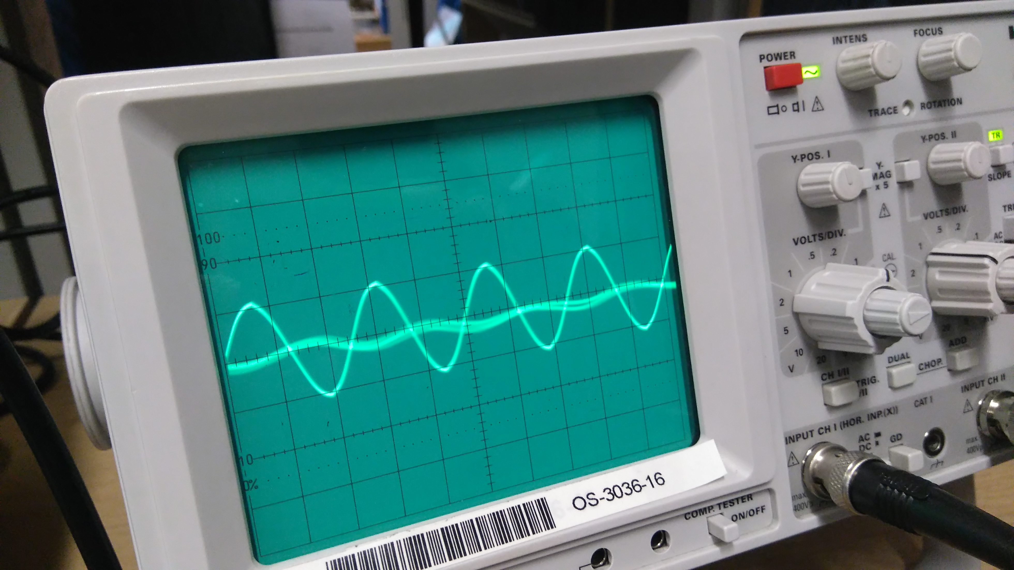

Figure – Oscilloscope when speaker was active (25cm away @ 2 kHz)

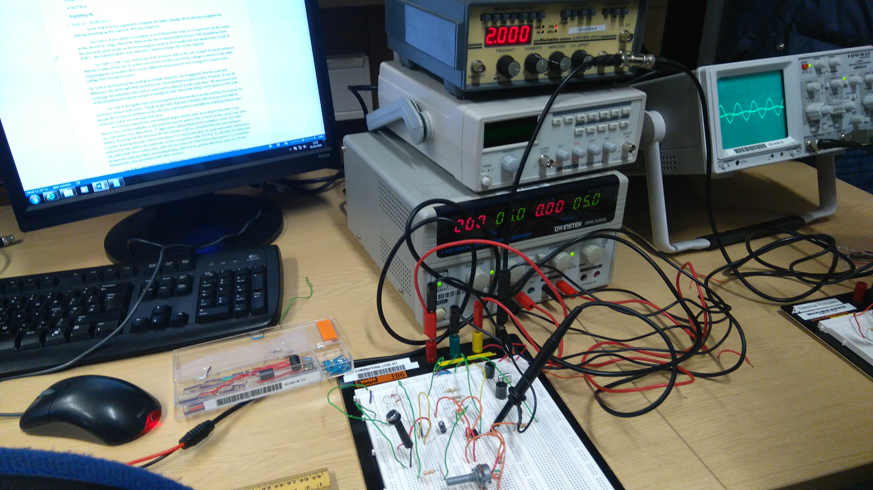

Figure – Overall view

These pictures were taken to prove that we had done this task. Each individual picture presents a different of each of the task. For example, Figure 10 and Figure 8 both show that the microphone was active and fully functioning. Figure 12 is an overall prospective of the whole setup. Figure 7 is how the breadboard was setup. These pictures show proof.

We chose the particular oscilloscope settings because we were able to easily identify the sin wave on the display clearly and were easy to get measurements from.

## Task 12 – Reflection

By undergoing a laboratory session on electronics, we were able to establish a basic understanding of how it all works. This really helped us in our degree as it is important to know how to make circuits and what is the purpose of certain equipment. As a group, this is our first time with the breadboard and it is good to get a hands-on practice with it to get to grips on how it works.

For Task 0, it was required to complete the table. Simply, all we did was complete the task by searching up the required. This was simple too.

For Task 1, it was simple to complete as we followed the steps as it requested. Set the meter to the 20-volt DC range. Placed the black probe tip on black (Gnd) terminal of the breadboard and the red multi-meter probe on the brown (Va) terminal of the breadboard and attained the result of 4.98 V. We followed all the steps that were required and got the result required.

For Task 2, Task 2 was a follow up of the previous task so this was straight-forward and all we did was to place probe tips to certain coloured terminal to record the voltage as shown in the table. Surprisingly we recorded 0.00 V on four different measurements and managed to acquire some voltage from the top two pairs.

For Task 3, we measured the reading accurately. However, we struggled to find the potential difference. We all thought that we had to use a formula that was given online. However, it was all confusing. We asked the tutor and we were told to subtract it with each other. We measured each of the breadboard terminals and got a reading on each. This made things much clearer on the task.

For Task 4, during this task we have learnt how to evaluate a resistor and how to measure its resistance using a multi-meter. Thanks to the table that was included in this task we were able to decode the resistance and find out its tolerance and resistance and difference between fixed value of resistor and its current measured value.   
 First resistor had brown, red and gold stripes. Brown value according to the table is one, black is zero, red for multiplier is 100 and tolerance for gold is ±5%. To find out the colour code value we used values of 1st digit colour, 2nd digit colour and multiplied it by multiplier colour 1 0 x 100= 1000 Ω. Knowing that the tolerance for this resistor is 5% we calculated that the real resistance could be anything between 950 Ω and 1050 Ω. For measured value we used multi-meter and banana plug test probes and for this particular resistor we got the value of 978 Ω. To calculate the difference we subtracted colour coded value 1000 Ω from measured value 978 Ω which gave us 22 Ω and then divided this value by 1000 Ω and multiplied by 100% and we got the difference value of 2.2% We followed the same procedure with other resistors.

For Task 5, we used formula – Ohm’s Law - I (current) =V (voltage) /R (resistance) to calculate current. First resistor’s resistance was 1000 Ω so the current is I = 12V/1000 Ω = 0.012 Amperes. Then we used RMS meter to get the real value which was 12.13mA = 0.01213A. To calculate power we used formula P = I x R so P = 0.0012A x 12 V = 0.0144 Watts.

For, Task 6, first of all, we have set up the wave generator to sine wave and changed the frequency to 1000 Hz and peak to peak voltage to 20 V by changing volts/div to 5V and adjusting amplitude knob on the wave generator. We have calculated that from the peak to the other peak there are 4 squares/divisions and each one of them is 5 Volts so the peak to peak value was 4 div x 5 volts = 20 volts. Peak voltage so from the middle of sine wave to peak was 2 divisions so 2 div x 5 volts = 10 V.

For calculating RMS we used peak voltage divided by $\sqrt{2}$ for sine wave, $\sqrt{3}$ for triangle wave and just the peak value for square wave. Therefore, for sine wave, we resulted in 10 and we need to use that to divide that by $\sqrt{2}$ and it would be 7.07. For triangle signal, it would be divided by $\sqrt{3}$ and for square it stays the same.

Our Time/Div setting was 0.2 ms so we could clearly see 2 periods of sine wave on our oscilloscope. To calculate period, we multiplied divisions between each sine wave so 5 by time/div so T = 5 div \* 0.2 ms = 1 ms. To calculate frequency, we used formula f = 1/T so f = 1 / 1 x 10 -3 = 1000 Hz. We followed the same steps for triangular and square wave except we changed the wave type in sine generator accordingly.

We all found this Task reasonably comfortable due to the factor of putting in extra hours of work to make sure we knew how to do the calculations, how to set up the oscilloscope and testing on each other to know we did it.

For Task 7, we had to create use a second signal generator by creating a lissajous figure. To do this, we added another BNC cable connecting it to 600 Hz output. However, to display this, we needed the X-Y button to be clicked. Once this was complete, we had change the frequency for each of the signal generator to create not too many loops. We all completed this task as soon as we were all finished the Task 6 test. We all thought that we needed to get our attention on Task 10 and 11, so once this task was complete, we can use the rest of our time to do Task 10 and 11.

For Task 8 and 9, this required research rather than using any equipment. As soon as I saw that I needed to research, rather than not wasting time, I completed these tasks for us to move on quickly because they were so many tasks to complete. Having do some tasks beforehand, this gives us more time to complete. I typed in each type of graphs present and filled it in. Task 9 was a problem, because when I typed it in, it only showed me different types of circuits. I wanted the same one, but I could not find one. However, I noticed the output and input through the circuits and noticed the difference between the two. This made me certain that these ones were the right ones.

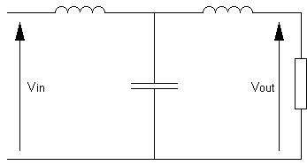For Task 10, we were tasked with constructing a low pass filter on the breadboard using the equipment listed in the lab guide. The circuit layout was established in task 9 (Figure 13). The top part of the circuit represents the 2 100 mH Inductance. The middle part represents the 4.7 nF Capacitance and the part on the right represents the 6.8 kΩ Resistance. This was constructed and shown in Figure 1. The only tricky part was to figure out how to get the Voltage in and out of the circuit, the rest was just making simple connections with jumper wires. For part b, we had to construct another low pass T section which connects with the one we already made, this is demonstrated in Figure 4. This was quite easy to do as the circuit was already there, it was just a matter of connecting them. For both of these parts, we plotted a graph of Amplitude (V) against Frequency (Hz), this is shown in the results of Task 10.

Figure – Low Pass Circuit

For Task 11, we were required to construct a microphone amplifier which boosts the signal of the microphone so it would be detectable and displayed on the oscilloscope. This task was the hardest as it took a long time of practicing and understanding the circuit to get it to work. As with Task 10, we were given a circuit which we need to replicate on the breadboard. This time, we need to connect the circuit to a 741 Operational Amplifier. Once the circuit was made and working, we outputted a signal from the generator into the speaker which gave a high-pitch beeping sound which the microphone would be able to pick up the signal and display that also on the oscilloscope. We measured the time delay for 5 different distances and again with a phase measurement. This is shown on the Speed of Sound graph in the Task 11 results. To calculate this, we needed to divide distance over time. We measured the distance in cm, then converted it to metres. We changed the different phases and got the average of the two, we used 1ms and 2ms. To calculate the speed, we do distance over time, see Table 1.

Overall, I think we worked well as a team. Especially when it got really hard at the end, we all took our time to make it work. We were motivated to complete all the tasks and the positive attitude enabled us to complete the work. The difficulty of task 11 made this laboratory challenging which makes it a lot of fun to overcome.

# Conclusion

In conclusion, we have learnt a lot of skills during this laboratory and got a lot of experience in using the breadboard, which in future, we would be really good at the next time we use it.

# References

Greenwich, University of. (2016) *Electrical Principals*, Greenwich, University of Greenwich, [online] Available at: <http://staffweb.cms.gre.ac.uk/~sp02/electronics/laboratory1.html>

(Accessed 19th January 2016).